CRUSADERS AND GREEN WAVE
METLIFE STADIUM – TUE, NOV 28 – 8 PM

TO DETERMINE WHO IS NJ’S #1
NOVEMBER 26 – ORADELL, NJ – This meeting between #2 Delbarton (10-1) and #1 Bergen Catholic (10-1) provides an interesting glimpse between programs who have very different pedigrees entering Tuesday’s Non-Public “A” Championship game. Since the playoff system began, the Green Wave have never won a Non-Public “A” or Non-Public IV Title, though 25 years ago, they did win a Non-Public III title. In the meantime, the Crusaders are the scourge of the “Big Parochials” winning 16 titles and in search of #17 this year. The championship would be Bergen’s 20th counting the three titles they earned prior to the current tournament system which began in 1974.
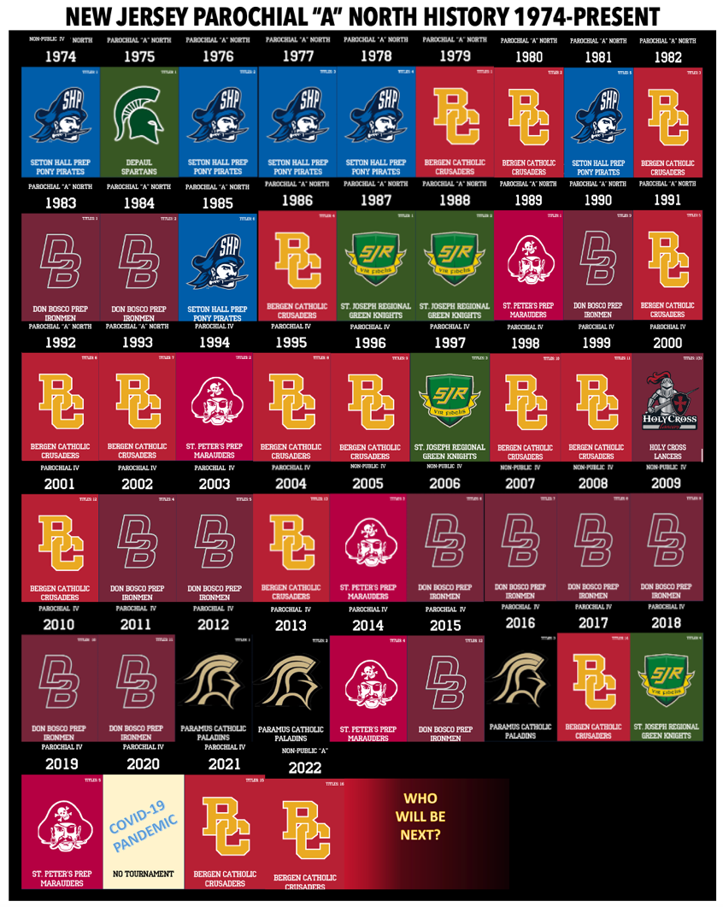
CRUSADER CHAMPIONSHIP WINNING COACHES
NOVEMBER 26 – ORADELL, NJ – Five different coaches have led the Crusaders to State Championships. Fred Stengel leads the pack with 9. Tony Karcich won three, followed by Coach Vito Campanile with two. His brother, Nunzio Campanile, and Bill Roca each won one title.
YEAR | COACH
1979 | TONY KARCICH
1980 | TONY KARCICH
1982 | TONY KARCICH
1986 | BILL ROCA
1991 | FRED STENGEL
1992 | FRED STENGEL
1993 | FRED STENGEL
1995 | FRED STENGEL
1996 | FRED STENGEL
1998 | FRED STENGEL
1999 | FRED STENGEL
2001 | FRED STENGEL
2004 | FRED STENGEL
2017 | NUNZIO CAMPANILE
2021 | VITO CAMPANILE
2022 | VITO CAMPANILE
METLIFE STADIUM
METLIFE STADIUM – TUE, NOV 28 – 8 PM

SPECIFIC TEAM INFORMATION
Team: Home - Lot A; Visitor - Lot A
Both teams enter the North End of the Stadium.
Security for personal possessions will not be provided.
Please be advised that Met Life Stadium only permits rear vehicle tailgating, no multi-space tailgating is permitted, and no alcoholic beverages will be permitted – Met Life security will confiscate any and all alcoholic beverages.

ADMISSION/TICKETS
MetLife Stadium is a Cash-Free Venue for all concession and retail purchases.
Tickets will be available online to purchase in advance. Please visit NJSIAA.org or Ticketmaster.com to purchase tickets.
The ticket prices for the Championship Playoff Games are as follows:
General Admission (Adults): $15.00
Students (K-12 & Sr. Citizens): $10.00
Parking $15.00

SEATING

Seating as a group on respective side of the field between the thirty-yard line. Visitors – (West Side – Section 133-143)

Home – (East Side – Section 108-118)

GENERAL INFORMATION
Parking: As directed by stadium staff. Lots open on Tuesday, November 28, 2023, at 3:00 PM
Admission Gates:
MetLife Gate open at 4:00 PM on Tuesday – November 28, 2023
Pepsi Gate opens at 3:00 PM on Tuesday – November 28, 2023

The MetLife Stadium Regulations –
Fans should NOT bring bags, backpacks, briefcases, umbrellas and similar items into the stadium. All items brought into the stadium will be inspected. Spectators can speed their entry into the stadium by leaving any carry in items behind. Stadium regulations prohibit bottles, cans, alcoholic beverages, coolers, whistles and balls, or any other items deemed unacceptable by stadium management from being brought into the facility.

It is the stadium and NJSIAA policy that posters, flags, noisemaking devices, pointed objects, laser pointers, air horns, poles, fireworks, weapons, powder and balloons are not permitted, and you are requested to notify your student body of this regulation. In addition, no mechanical noise-making devices will be permitted.

Pat-downs and the Meadowlands K-9 Corps will be utilized in regard to any of the above.
(See MetLifeStadium.com for additional information.)

NJSIAA E-PROGRAM

https://www.flipsnack.com/tpg2020/2023-njsiaa-football-championship-program-metlife/full-view.html

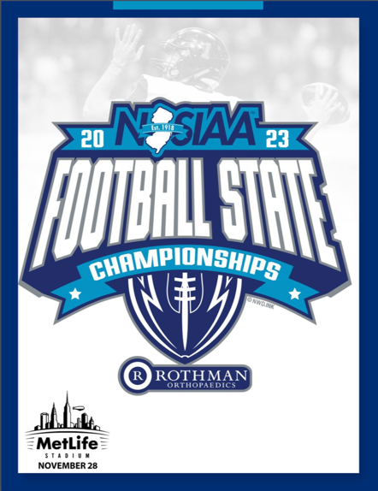

SR SOCCER STARS HONORED

NOVEMBER 25 – ORADELL, NJ – Seven members of the varsity soccer team earned All-County Honors for the Crusaders including three first-teamers, three second teamers and one on the third team. In addition, twelve members earned All-Division Honors for the 2023 BNC United Division Champions.

ALL-BERGEN COUNTY
FIRST TEAM
Sebastian Ortega, Bergen Catholic, senior
Cosimo Tristani, Bergen Catholic, senior
Joseph Lee, Bergen Catholic, senior
SECOND TEAM
Ryan Chong, Bergen Catholic, senior
Luca Nazor, Bergen Catholic, senior
Andrew Blodgett, Bergen Catholic, senior
THIRD TEAM
Graham Ewers, Bergen Catholic, senior

ALL-BIG NORTH - UNITED DIVISION
FIRST TEAM
Backers
Cosimo Tristani, Bergen Catholic, senior
Joseph Lee, Bergen Catholic, senior
Midfielders
Luca Nazor, Bergen Catholic, senior
Graham Ewers, Bergen Catholic, senior
Ryan Chong, Bergen Catholic, senior
Forwards
Sebastian Ortega, Bergen Catholic, senior
Goalie
Andrew Blodgett, Bergen Catholic, senior
SECOND TEAM
Backers
Kevin Schliem, Bergen Catholic, senior
Daniel DeBono, Bergen Catholic, junior
Midfielders
Guglielmo Picariello, Bergen Catholic, senior
Tyler Ferris, Bergen Catholic, senior
HONORABLE MENTION
Nico Angione, Bergen Catholic, senior, midfielder

CROSS-COUNTRY FINSHES #20 IN BERGEN COUNTY
NOVEMBER 26 – ORADELL, NJ – NorthJersey.com announced its Cross-Country Top 25 and BC finished #20 overall. Senior Brendan O’Rourke earned a Top 10 spot on the Greystone Park Course List, finishing 10th overall with a time of 17:36.
BIRD OF THE WEEK
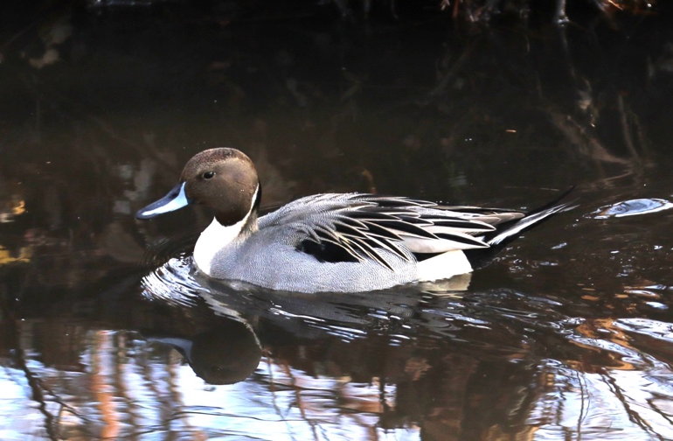NORTHERN PINTAIL
NOVEMBER 24 – TEANECK, NJ – I had a nice time going for a day-after-Thanksgiving-Day walk with my mom on Friday. We stopped down Fyke Lane, across from Holy Name Hospital. Just past Thomas Jefferson Middle School, on the opposite side of the street, you may very well find a car with a BC Class of 2027 sticker and the entrance to the Teaneck Creek Conservancy. (I can’t promise the car will be there in the future. I just liked the sticker.) The other entrances to the park are over by the Glenpoint and off Puffin Lane in Teaneck if you’re ever on Teaneck Road.
A birding friend, let’s call him Rod, alerted us to the fact that there was a Northern Pintail among the Mallards in the creek as we entered. The bird I photographed (no, it’s not a snowy owl, Sly) is that drake. A drake is a male duck.
Pintails, as you might guess, have a tail that tapers like a pin in the end. They have a brown head with a crisp white stripe that runs up the back side of either side of its neck. Its bill has two colors: bluish grey on the outsides and black in the center.
Northern Pintails are dabbling ducks. Like mallards, American Black Ducks, Northern Shovelers, Gadwall and others, they tip over to search for food in shallow ponds or streams. Other ducks are divers. They will dive under the water in search of invertebrates and other delicacies. Those are ducks like: ruddy ducks, buffleheads, mergansers, and sea ducks like long-tailed ducks, scoters and others.

PINTAILS:
When it comes to breeding, Northern Pintails don't waste any time. They start nesting as soon as the ice starts to thaw, arriving by late April in places as far north as the Northwest Territories, Canada.
Northern Pintails migrate at night at speeds around 48 miles per hour. The longest nonstop flight recorded for a Northern Pintail was 1,800 miles.
The oldest recorded Northern Pintail was a male, and at least 22 years, 3 months old when he was shot in Saskatchewan, Canada in 1994.

Want to learn more about birds? Join the Birding Crusaders OR visit https://www.allaboutbirds.org
Our Father
Our Father, Who art in Heaven
Hallowed be Thy Name
Thy Kingdom Come.
Thy will be done
On Earth as it is in Heaven.
Give us this day our daily bread.
And forgive us our trespasses
As we forgive those who trespass against us.
And lead us not into temptation.
But deliver us from evil. Amen.

Hail Mary
Hail Mary, full of grace
The Lord is with You
Blessed are you among women
And blessed is the fruit of your womb, Jesus.
Holy Mary, Mother of God
Pray for us sinners
Now and at the hour of our death.
Amen.

Glory Be
Glory be to the Father and to the Son and to the Holy Spirit,
as it was in the beginning, is now and ever shall be,
Painting by,
Mr. Nedco Bucev
world without end. Amen

Act of Contrition
My God, I am sorry for my sins with all my heart.
In choosing to do wrong and failing to do good,
I have sinned against you whom I should love above all things.
I firmly intend, with your help, to do penance, to sin no more, and to avoid whatever leads me to sin.

Serenity Prayer
God, grant me the
Serenity to accept the things I cannot change,
Courage to change the things I can and
Wisdom to know the difference.
Amen.
The Jesus Prayer
The Golden Rule
Love one another as I have loved you.

Lord Jesus Christ, Son of God,
have mercy on me, a sinner.

Blessed Edmund Rice
Creator God, we thank you for the life and work of this gifted man, Blessed Edmund Rice. He opened his heart generously to Christ present and appealing to him in the poor who were oppressed by poverty and injustice. May we follow his example of faith and generosity. O God, give us the courage and compassion of Blessed Edmund as we seek to support one another, protect the vulnerable and care for the earth, our common home. We make this prayer through Jesus Christ Our Lord. Amen.
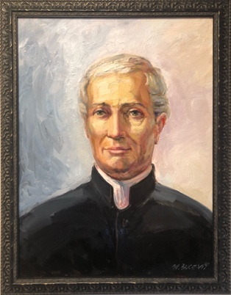
Apostles’ Creed
I believe in God, the father almighty, Creator of heaven and earth, and in Jesus Christ, his only Son, our Lord, who was conceived by the Holy Spirit, born of the Virgin Mary, suffered under Pontius Pilate, was crucified, died and was buried; he descended into hell; on the third day he rose again from the dead; he ascended into heaven, and is seated at the right hand of God, the Father almighty; from there He will come to judge the living and the dead. I believe in the Holy Spirit, the holy catholic Church and the communion of saints, the forgiveness of sins, the resurrection of the body and life everlasting. Amen

Philippians 4:13
I can do all things through Christ
who strengthens me.

Traditional Grace Before Meals
Bless us, O Lord, and these, thy gifts
Which we are about to receive from
thy bounty, through Christ, Our Lord. Amen

And this is the will of Him who sent me, that I shall lose none of all those He has given me but raise them up at the last day.

DEUS VULT – JOHN 6:39

Make me a channel of your peace
(Prayer of St. Francis)
¶1 Make me a channel of your peace
Where there is hatred let me so your love
Where there is injury, your pardon Lord
And where there’s doubt true faith in You.
¶2 Make me a channel of your peace
Where there’s despair in life let me bring hope
Where there is darkness only light
And where there’s sadness ever joy.
¶3 Oh, Master grant that I may never seek
So much to be consoled as to console.
To be understood as to understand.
To be loved as to love with all my soul.
¶4 Make me a channel of your peace.
It is in pardoning that we are pardoned
In giving to all men that we receive
And in dying that we’re born to eternal life.
¶3
¶2
Prayer for Peace
(ESPECIALLY FOR RUSSIA AND Ukraine)
Lord Jesus Christ, who are called the Prince of Peace, who are yourself our peace and reconciliation, who so often said, "Peace to you," grant us peace. Make all men and women witnesses of truth, justice, and brotherly love. Banish from their hearts whatever might endanger peace. Enlighten our rulers that they may guarantee and defend the great gift of peace. May all peoples on the earth become as brothers and sisters. May longed for peace blossom forth and reign always over us all.
Amen
- Pope Saint John Paul II

An Irish Blessing
May the road rise up to meet you.
May the Wind be always at your back.
May the sunshine warm upon your face,
The rains fall soft upon your fields,
And, until we meet again,
May God hold you in the palm of His hand.

Come Holy Spirit
Come Holy Spirit, fill the hearts of your faithful and
Kindle in them the fire of your love. Send forth your Spirit and they shall be created, and You shall renew the face of the earth.
O, God, who by the light of the Holy Spirit, did instruct the hearts of the faithful, grant that by the same Holy Spirit, we may be truly wise and ever enjoy in Her consolations through Christ Our Lord, Amen.

Superman Grace
Before Meals
We thank you Lord, for giving us food.
We thank you Lord, for giving us food.
And for our daily bread
When we need to be fed.
We thank you Lord, for giving us food.
Duh, Duh, Duh, Duh, Dum.

Addams Family Grace
Before Meals
We thank you for this food, Lord.
For Mom and Dad and you, Lord.
We thank you for this food, Lord.
And for our family.
Duh, duh, duh, duh, SNAP, SNAP.
Duh, duh, duh, duh, SNAP, SNAP.
Duh, duh, duh, duh.
Duh, duh, duh, duh.
Duh, duh, duh, duh, SNAP, SNAP.
LITURGICAL CALENDAR 2023
The Ten Commandments

I am the Lord your God: you shall not have strange gods before me.
You shall not take the name of the Lord your God in vain.
Keep holy the Lord’s Day.

Honor your father and mother.

You shall not kill.
You shall not commit adultery.
You shall not steal.
You shall not bear false witness against your neighbor.
You shall not covet your neighbor’s wife.
You shall not covet your neighbor’s goods.
- ORDINARY TIME (Jan 6-Feb 21)
- ASH WEDNESDAY (Feb 22) LENT
- HOLY WEEK (Apr 2-8)
- HOLY THURSDAY (Apr 6)
- GOOD FRIDAY (Apr 7)
- EASTER (Apr 9)
- PENTECOST (May 28)
- ORDINARY TIME (Jun 4- Dec 2)
- ADVENT (Dec 3 – Dec 24)
- CHRISTMAS (Dec 25 – Jan 7, 2024)
Footprints in the Sand
One night I dreamed a dream.
As I was walking along the beach with my Lord.
Across the dark sky flashed scenes from my life.
For each scene,
I noticed two sets of footprints in the sand,
One belonging to me and one to my Lord.
After the last scene of my life flashed before me,
I looked back at the footprints in the sand.
I noticed that at many times along the path of my life,
especially at the very lowest and saddest times,
there was only one set of footprints.
This really troubled me, so I asked the Lord about it.
"Lord, you said once I decided to follow you,
You'd walk with me all the way.
But I noticed that during the saddest and most troublesome times of my life,
there was only one set of footprints.
I don't understand why, when I needed You the most, You would leave me."
He whispered, "My precious child, I love you and will never leave you
Never, ever, during your trials and testings.
When you saw only one set of footprints,
It was then that I carried you."
“Rivers do not drink their own water, trees do not eat their own fruit, the sun does not shine on itself, and flowers do not spread their fragrance for themselves. Living for others is a rule of nature. We are all born to help each other. No matter how difficult it is, life is a good when you are happy, but much better when others are happy because of you.”
Pope Francis

