APES Summer Work: Unit 0

Chapter A: The Environmental Challenges We Face

- Read through the attached slides and answer the following questions
- Each question will be worth 2-points
- Highlight each answer
- Research the importance of the following legislation:
- National Environmental Policy Act
- Pollution Prevention Act
- Montreal Protocol
- Kyoto Protocol

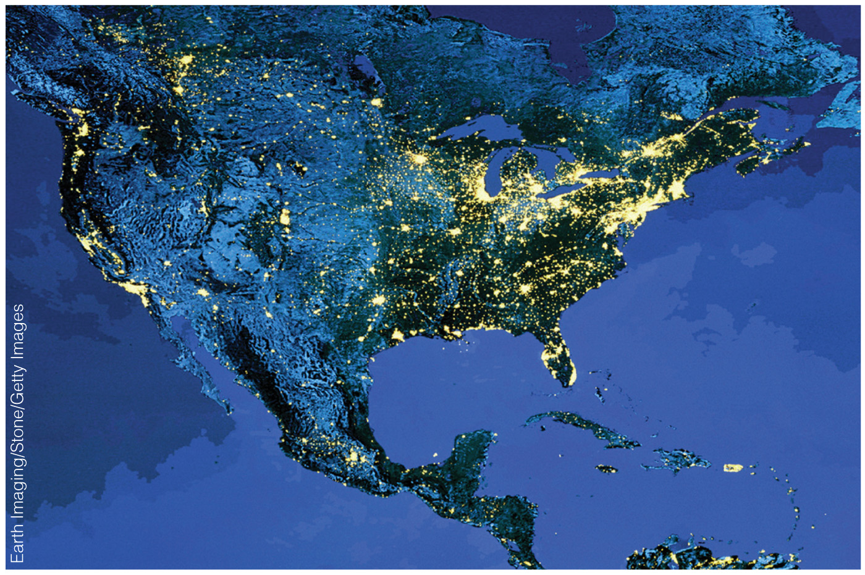

- This partial image of North America represents:

1. A satellite view of the continent taken during the day to highlight areas of bright sunlight.
2. The areas in yellow represent major metropolitan areas.
3. The areas in yellow represent major human population centers.

a) 1 only
b) 2 only
c) 3 only
d) Both 2 and 3 can be interpreted from the image.

2) Which of the following statements associated with poverty is CORRECT?

1. Poverty is associated with a short life expectancy, illiteracy, and inadequate access to health services, safe water, and balanced nutrition
2. The number of people living in poverty has been steadily declining and today less than one billion people live in poverty worldwide.
3. Poverty is a condition in which people are unable to meet their basic needs for food, clothing, shelter, education, or health.

a) 1 only
b) 2 only
c) 3 only
d) Both 1 and 3 apply as descriptions of poverty.

3) Which of the following describes a highly developed country?

a) Countries with low rates of population growth and high per person incomes.
b) Countries with complex industrialized bases such as Mexico and Thailand.
c) Countries with low levels of industrialization, very high rates of population growth, very high infant mortality rates, and very low per person incomes.
d) Countries with abundant unskilled labor but with limited capital for investment.

4) The global fertility rate is currently 1.2 children per woman and is expected to continue to decline. True/False

5) How do moderately developed countries MOST differ from highly developed countries?

a) They have much higher infant mortality rates
b) They are mostly rural economies
c) They have much lower levels of pollution.
d) They have fewer opportunities for income, education, and healthcare.

6) The highly developed countries represent how much of the world’s population?

a) 18%
b) 25%
c) 30%
d) 70%

7) 86% of the global resource consumption of _______ is accounted by HDCs.

8) Non-renewable resource IS TO renewable resource AS

a) living is to non-living
b) limited supply is to sustainable supply
c) tree is to coal
d) wind energy is to fossil fuel energy

9) Renewable resources are:

a) resources such as fossil fuels that replenish within a reasonable duration on the human timescale.
b) resources such as fish that can be replaced by natural processes on a fairly rapid scale provided they are not overexploited in the short term
c) resources such as forests that are impossible to overexploit as trees grow so fast
d) resources such as minerals because we can efficiently extract, refine, and recycle them

10) What does the phrase “environmental sustainability” imply?

a) The actions of humans directly impact the wellbeing of the natural environment.
b) Future generations will have the resources necessary for quality of life.
c) A shared global responsibility is necessary for conservation practices.
d) All of the above are implied by environmental sustainability.

11) The interdisciplinary study of humanity’s relationship with other organisms and the non-living physical environment is termed:

a) ecology
b) sociology
c) political science
d) environmental science

12) The scientific analysis and the study of interactions among organisms and their environment is called ________.

13) How does science obtain knowledge about the world?

a) By an interactive process of experimentation, which refines hypotheses until they are finally proven to be the absolute truth.
b) By relying on scientific authorities and the massive amount of knowledge already obtained to explain new data.
c) By systematically gathering evidence and discarding potential explanations that do not fit the evidence, and refining those that do fit the evidence.
d) By conducting experiments designed to support hypotheses as being correct beyond reasonable doubt.

14) What is the correct sequence of steps in the scientific method?

- State the problem
- II. Analyze and interpret the data
- III. Develop a hypothesis
- IV. Share the results with other scientists
- V. Design and perform an experiment to test the hypothesis

a) I – II – III – IV – V
b) III – I – V – II – IV
c) I – III – V – II – IV
d) V – IV– III – II – I

15) The interdisciplinary study of humanity’s relationship with other organisms and the non-living physical environment is termed:

a) ecology
b) sociology
c) political science
d) environmental science

